ST. STEPHEN’S SCHOOL
PHYSICS 2B

END TOPIC TEST
HEATING & COOLING

Name:

Teacher:

INSTRUCTIONS

- You have 1 hour to complete the test.
- It is recommended that you take a few minutes to read the paper through carefully.
- Answer all questions in the space provided.
- Use BLACK or BLUE pen only.
- Scientific calculators are permitted for this test (NO GRAPHICS CALCULATORS).
- Unmarked physic constant sheets are permitted for this test
Test Score:

60

Percentage:

POST ASSESSMENT REVIEW
(to be completed upon return of your marked paper)

Which topics / questions did I do best at?

________________________________________________________________________
________________________________________________________________________
________________________________________________________________________
________________________________________________________________________

Which topics / questions could I have improved on?

________________________________________________________________________
________________________________________________________________________
________________________________________________________________________
________________________________________________________________________

What is my new goal for next time?

________________________________________________________________________
________________________________________________________________________
________________________________________________________________________
________________________________________________________________________

Class Average:
Additional Teacher Comments (if desired):
Class Range:

Parent / Guardian Comment (if desired):

Parent / Guardian Signature (required):

This test is divided into three sections:

SECTION A: Short Answer (30% of total marks) 18 marks

SECTION B: Problem Solving (50% of total marks) 30 marks

SECTION C: Interpretation & Comprehension (20% of total marks) 12 marks

SECTION A: Short Answer (18 marks)

- Describe two physical properties of materials that change with temperature.
[4 marks]

- State the principal of conservation of energy as applied to heat transfers.
[2 marks]

- Explain what the following means:
- The specific heat capacity of water is 4.186 x 10³ J kg⁻¹ K⁻¹.
[1 mark]

- The latent heat capacity of vapourisation of water is 2.25 x 10⁶ J kg⁻¹.
[1 mark]

- The freezing unit of a refrigerator is usually placed at the top of the unit, but in an electric kettle the element is placed at the bottom of the appliance. Explain why.
[4 marks]

- What is internal energy?
[2 marks]

- An object at a temperature of -10ºC is placed in a closed system at thermal equilibrium.
“Because the object is so cold it is unable to transfer heat energy”
Comment on the statement in italics.
[4 marks]

SECTION B: Problem Solving (30 marks)

- On the stove is a kettle full of pure water.
- The water has started to boil rapidly. What is the most likely temperature of the water?
[1 mark]

- Five minutes later, the water in the kettle is still boiling. What is the most likely temperature of the water now?
[1 mark]

- What do you think is a likely temperature of the steam above the boiling water in the kettle? Explain your answer.
[2 marks]

- Nick takes two cups of water at 40ºC and mixes them with one cup of 10ºC. What is the most likely temperature of the mixture. State any assumptions you make.
[4 marks]

- a) A saucer of water is placed on a kitchen bench . The liquid begins to evaporate.
Explain how/why evaporation causes an initial decrease in the temperature of the liquid.
[3 mark]

- What factors affect the rate of evaporation?
[2 marks]

- Given the latent heat of vaporisation of water at skin temperature (33ºC) is 2.42 x 10⁶ Jkg⁻¹ and the specific heat capacity of the human body is 3500 Jkg⁻¹K⁻¹. Calculate:
- How much heat would a 57 kg athlete lose if they evaporate 6L of water through perspiration?
[2 marks]

- How much would the athlete’s body temperature have raised if they did not lose this heat through perspiration?
[2 marks]

- Adding hot water to a bath of cold water will increase the temperature of bath water.

- Explain why this statement is true.
[2 marks]

- If the hot water comes out of the tap at 45ºC and the bath originally had 35 L of water at 18ºC, how much hot water would you need to add if you wanted the final temperature of the bath to be 21ºC.
[3 marks]

- The diagram is of the basic features of a simple refrigeration system.

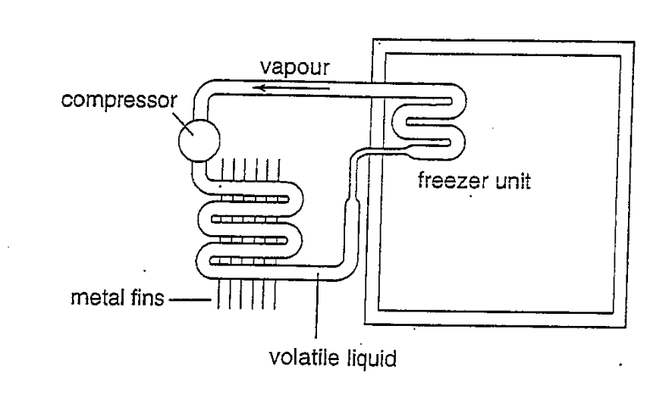

- Explain what happens in the pipes of the freezer unit, stating clearly how this section of the system manages to reduce temperature.
[4 marks]

- What is the purpose of the metal fins?
[2 marks]

- Explain how the law of conservation of energy applies if the inside of the freezer gets colder.
[2 marks]

SECTION C: Interpretation & Comprehension (12 marks)

ENGINE MAKER SEEKS OUT CERAMICS

In a bid to develop new material for aircraft engines, Rolls Royce installed a team of materials and stress engineers and designers in the technology part of Warwick University late year, and the team is now beginning to start work.

The idea, said Phillip Ruffles, the company’s technical director, is to form an interdisciplinary team to work closely, with academics from the university’s physics department to develop components made principally from ceramics and glass.

Now that the equipment and researchers are in place, the teams first task will probably be to develop components for the after burners of the engine of the European fighter air craft.

The advantage of ceramics is that they will work at higher temperatures than metals, which reach their limit at 850ºC and 950ºC, and have a higher specific heat capacity. Above that temperature, metal components must be cooled using air pressure through the engine, thus reducing energy efficiency. With ceramic components the cooling can be omitted. Ceramics are also lighter.

The disadvantage of ceramics is that they are more brittle than metals. To increase their strength, they can be reinforced with fibres, but this makes them more complex to manufacture and design than metals. So far, says Ruffles, ceramics have not been used in aircraft engines.

Rolls Royce hopes its first composite ceramic components made from silicon carbide for the Eurofighter engine, will develop in three to five years. The components would not be load bearing and operate at 1000ºC.

The next stop will be to replace static components in the engine turbines with ceramics. At first, these would work at about 1000ºC. Eventually, static components in hotter parts of the turbine – at temperatures up to 1400ºC – would be replaced by composite ceramics.

The eventual goal, though not until next century, would be to make moving, load bearing parts, such as turbine blades, from ceramic composites. But the stress on these components currently rules out the use of such brittle components.

The Warwick team will also develop composite glass materials form components in engines. “This work,” says Ruggles, “is still speculative. The idea, however, is that composite glass would replace metal components that do not need cooling, possibley in the compressor. Their main advantages is that they are lighter in weight than metal.”

In future, Ruffles believes that the development of new materials will involve much more international collaboration. “The cost of developing components from these new materials is substantially higher than for metals. In particular, designers need to work out how to weave reinforcing fibre into the composite ceramics for making into components of complex shapes and to work out how to transfer loads.”

New Scientist, 8 September 1990

- What are the advantages of using ceramic materials rather than metal engines?

[3 marks]

- In terms of the components tendency to “heat up”, what is the significance of the ceramics having a higher specific heat capacity than the metals.
[2 marks]

- What are the disadvantages of replacing metals with ceramics?
[3 marks]

- Why is the immediate goal to develop only ceramic components for static parts of engines?
[2 marks]

- One of the goals of using ceramic materials in engines is to run them at higher temperatures. Why would this be an advantage?
[2 marks]

END OF TEST

